PRACTICE PROBLEM:

1. Program to Print the Perfect squares between two intervals

def CS(a, b):

c = 0 # initialize result

for i in range (a, b + 1):

j = 1;

while j \* j <= i:

if j \* j == i:

c = c + 1

j = j + 1

i = i + 1

return c

a = 9

b = 25

print("Count of squares is:", CS(a, b))

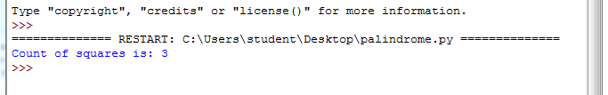

1. Program to Count the digits in the given number.

import re as r

a=input("Enter the input");

b=r.findall('\d',a)

print(len(b))

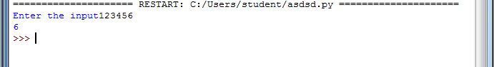

1. Program to calculate sum of digits.

n=int(input("Enter a number:"))

t=0

while(n>0):

dig=n%10

t=t+dig

n=n//10

print("The total sum of digits is:",t)

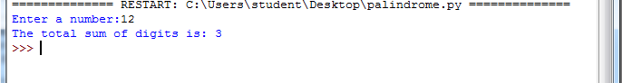

1. Program to replace every element with the greatest element on right side

import re as r

print("Enter the input")

a=input()

b=(r.findall('\d',a))

b.sort()

for i in b:

print(i, end="")

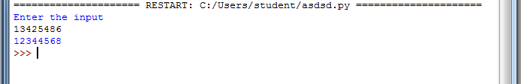

1. Program to perform circular Array Rotation

l=list(map(int,input().split()))

for k in l:

temp=l[0]

for i in range(1,len(l)):

l[i-1]=l[i]

l[len(l)-1]=temp

print(l)

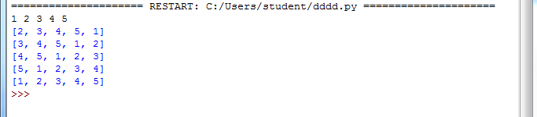

1. Program to add two matrix

X = [[1,2,3],

[4 ,5,6],

[7 ,8,9]]

Y = [[9,8,7],

[6,5,4],

[3,2,1]]

res = [[0,0,0],

[0,0,0],

[0,0,0]]

for i in range(len(X)):

for j in range(len(X[0])):

res[i][j] = X[i][j] + Y[i][j]

for r in res:

print(r)

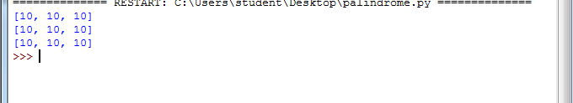

1. Reverse the given String

print("Enter the input")

a=input()

rev=a[::-1]

print(rev)

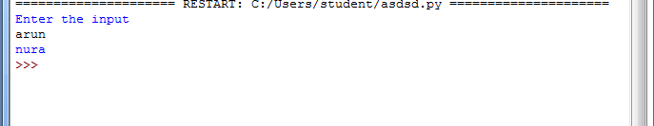

8. Check the given string is Palindrome

print("Enter the input")

a=input()

rev=a[::-1]

print(rev)

if(a==rev):

print("Palindrome")

else:

print("Not Palindrome")

